LIVE WEATHER APP

Aim:

The aim of the Live Weather App is to deliver accurate and real time weather information to users in a user-friendly manner, enhancing their ability to make informed decisions based on current and forecasted weather conditions.

Objectives:

Real-time Updates:

Provide users with the latest weather information, ensuring real-time updates to reflect current conditions.

User-Friendly Interface:

Design an intuitive and visually appealing interface that caters to users of varying technical expertise.

Accurate Forecasting:

Utilize reliable weather APIs to deliver precise and dependable weather forecasts, including details such as temperature, humidity, wind speed, and more.

Location-Based Services:

Implement geolocation features to automatically detect and display weather information for the user's current location.

Graphical Representation:

Incorporate graphical elements, such as charts and icons, to visually represent weather trends and conditions for better user comprehension.

Alerts and Notifications:

Enable push notifications to alert users about significant weather changes or severe conditions, enhancing safety and preparedness.

Customization:

Allow users to customize the app settings, including preferred units (e.g., Celsius or Fahrenheit) and notification preferences.

Offline Capability:

Ensure basic functionality even in offline mode, allowing users to access cached weather data when internet connectivity is limited.

Historical Data Access:

Optionally provide access to historical weather data, allowing users to review past weather patterns and trends.

Cross-Platform Compatibility:

Develop the app to be compatible with various platforms, ensuring a consistent experience across devices and operating systems.

Energy Efficiency:

Optimize the app's performance to minimize battery consumption, enhancing the overall user experience.

User Feedback Mechanism:

Include a feedback system for users to report inaccuracies and provide suggestions, facilitating continuous improvement and refinement.

Educational Component:

Optionally incorporate educational content to enhance users' understanding of weather phenomena and promote weather literacy.

Community Engagement:

Foster a sense of community by integrating social features, allowing users to share weather updates or insights.

By achieving these objectives, the Live Weather App aims to serve as a reliable and user-centric tool for accessing weather information, contributing to improved decision-making and user satisfaction.

Source Code:

import requests

from tkinter import *

# OpenWeatherMap API key (replace with your own key)

API_KEY = 'df71abbdc42517b11de330c7629c4a74'

def get_weather(city):

    url = f'http://api.openweathermap.org/data/2.5/weather?q={city}&appid={API_KEY}&units=metric'

    response = requests.get(url)

    data = response.json()

    if data['cod'] == '404':

        return None  # City not found

    else:

        city_name = data['name']

        country = data['sys']['country']

        temperature = data['main']['temp']

        weather_description = data['weather'][0]['description']

        return f'{city_name}, {country}\nTemperature: {temperature}°C\nWeather: {weather_description}'

def search():

    city = city_entry.get()

    weather_info = get_weather(city)

    if weather_info:

        result_label.config(text=weather_info)

    else:

        result_label.config(text='City not found. Please try again.')

# GUI setup

app = Tk()

app.title('Weather App')

# Widgets

city_label = Label(app, text='Enter City:')

city_entry = Entry(app)

search_button = Button(app, text='Search Weather', command=search)

result_label = Label(app, text='Weather Information Will Appear Here', wraplength=300, justify='left')

# Layout

city_label.grid(row=0, column=0, padx=5, pady=5)

city_entry.grid(row=0, column=1, padx=5, pady=5)

search_button.grid(row=0, column=2, padx=5, pady=5)

result_label.grid(row=1, column=0, columnspan=3, padx=10, pady=10)

# Run the application

app.mainloop()

Output:

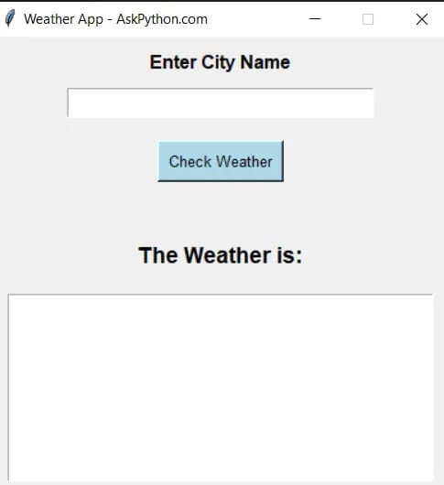

Conclusion:

In conclusion, the live weather app provides users with real-time and accurate weather information, enhancing their ability to plan and make informed decisions. With features such as hourly forecasts, radar maps, and location-based alerts, the app ensures a seamless and personalized experience. Its user-friendly interface and reliable data sources make it a valuable tool for staying connected to the ever-changing weather conditions. Embracing innovation and convenience, this app is a must-have for anyone seeking up-to-date weather insights at their fingertips.